Resolution of a Signal

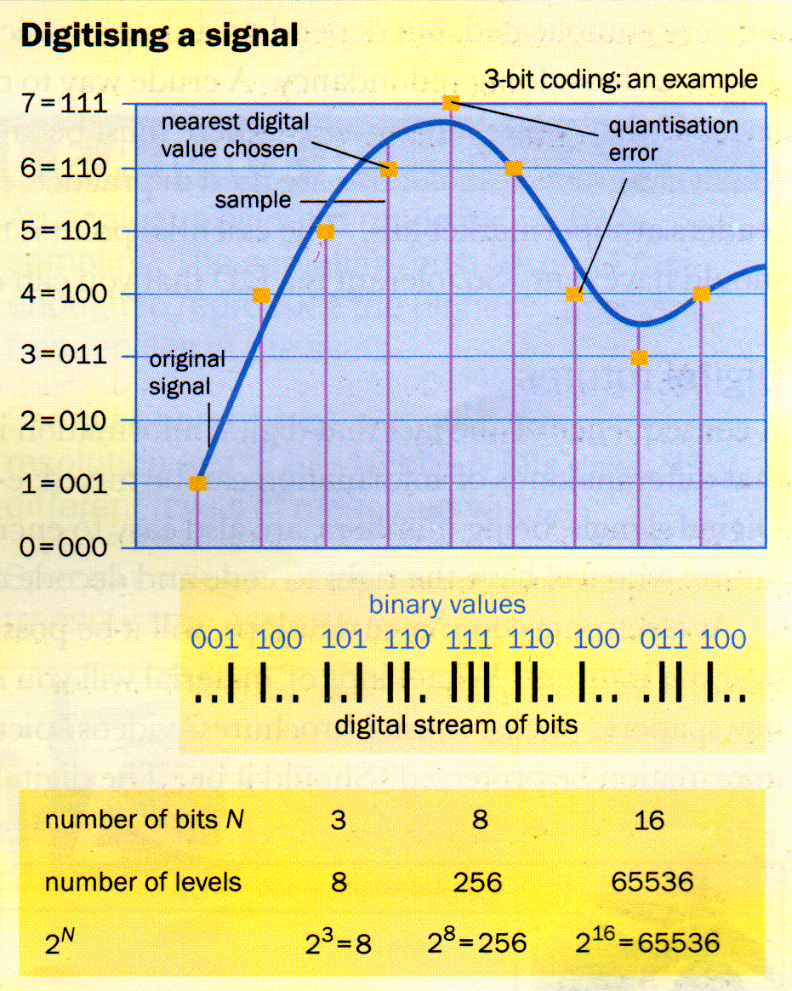
The resolution of the samples will also have a large effect on the quality of the reconstructed signal. Telephone signals are encoded using an 8-bit Analogue to Digital Converter. This gives 256 possible levels for each sample – good enough for comprehensible speech.

CD sound is encoded at a much higher resolution – 16 bits per sample – giving 65536 possible levels for each sample.

Resolution of a Signal

The resolution of the samples will also have a large effect on the quality of the reconstructed signal. Telephone signals are encoded using an 8-bit Analogue to Digital Converter. This gives 256 possible levels for each sample – good enough for comprehensible speech.

CD sound is encoded at a much higher resolution – 16 bits per sample – giving 65536 possible levels for each sample.

