For each example below write down how energy is being **transferred**.

Use some of these words to fill in the boxes:

kinetic thermal gravitational potential sound electric

nuclear elastic chemical light

C:\Documents and Settings\Han\Local Settings\Temporary Internet Files\Content.IE5\A6Z5DIUT\MC900295823[1].wmfExample: Turning on the kettle

Electrical Thermal

1. C:\Documents and Settings\Han\Local Settings\Temporary Internet Files\Content.IE5\E2809509\MC900319358[1].wmfDropping a ball

Gravitational

potential

1. Connecting a battery to a circuit

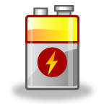

1. Switching on a light bulb



+

**Extension Challenge!**

Can you come up with your own example?